# Food Service Website

### A MINI PROJECT REPORT

#### Submitted by

#### Group: G12

**Aniket Sharma,2410990920,**

**Aarnav Singla, 2410990889,**

**Anshvesh Baghla , 2410990932,**

#### in partial fulfillment for the award of the degree of

## BACHELOR OF ENGINEERING

***in***

CSE



**CHITKARA UNIVERSITY**

**CHANDIGARH-PATIALA NATIONAL HIGHWAY**

**RAJPURA (PATIALA) PUNJAB-140401 (INDIA)**

##### October,2024

###### TABLE OF CONTENTS

| **Sr.no** | **Section** | **Page no** |
| --- | --- | --- |
| **1.** | Introduction | 1 |
| **2.** | Problem Statement | 2 |
| **3.** | Technical Details | 3 |
| 4. | Key Features | 4 |
| **5.** | Projects Highlights | 5-8 |
| **6.** | Bonus Feature | 9 |
| **7.** | Conclusion | 10 |
| **8.** | References and links used | 11 |

###### 

###### 1

**Introduction**

**Project Title: Food Service Website**

**Team Members:**

* **Aniket Sharma**
* **Aarnav Singla**
* **Anshvesh Baghla**

**Project Overview:**

**Project Goal:**

**To create a comprehensive online platform that connects food service providers (restaurants, cafes, caterers) with customers, offering a seamless and convenient way to discover, order, and enjoy a variety of food options.**

**Key Features:**

* **Restaurant Directory:**

**A searchable database of local food establishments, including details like cuisine, location, menu items, and customer reviews.**

* **Online Ordering:**

**A user-friendly interface for customers to place orders directly from the website.**

* **Customer Reviews and Ratings:**

**A system for customers to rate and review restaurants, helping others make informed decisions.**

* **Loyalty Programs:**

**Rewards and incentives for repeat customers, such as discounts.**

* **Online Ordering System:**

**Integrate a robust online ordering platform with features like menu management, order processing, and payment integration.**

2

Problem Statement

The current food ordering process for restaurants often involves long wait times, limited menu options, and inefficient communication with customers.

Our food service website is eliminating all these problems, it will help customers very much and grow company business also.

Background:

Many restaurants struggle to manage online orders and maintain consistent quality and service.

Research:

A recent survey found that 80% of respondents prefer to order food online rather than dining in. A study by [McKinsey &Company]revealed that inefficient order processing can lead to increased customer churn and decreased revenue.

3

Technical Details

Key Components and Technologies:

HTML (Hypertext Markup Language):

The fundamental building block of websites

Defines the structure and content of a webpage using tags

Examples of HTML tags: <html>, <head>, <body>, <p>, <img>

CSS (Cascading Style Sheets):

Controls the presentation (style) of HTML elements

Defines how elements are displayed, including colors, fonts, layout, and spacing

Examples of CSS properties: color, font-size, margin, padding, display

JavaScript:

A programming language that adds interactivity and dynamic elements to websites.

Can be used to create animations, handle user input, and communicate with servers.

Examples of JavaScript uses: Interactive maps

4

Key Features

->User Experience (UX) and User Interface (UI)Clear Navigation

->Intuitive navigation and easy-to-use design for a seamless user experience

->Clear and concise information presentation for efficient decision-making.

->Efficient and fast payment system

5

Project Highlights

Toggle Dark Mode and Variety of dishes with best user interface and overview of dishes:

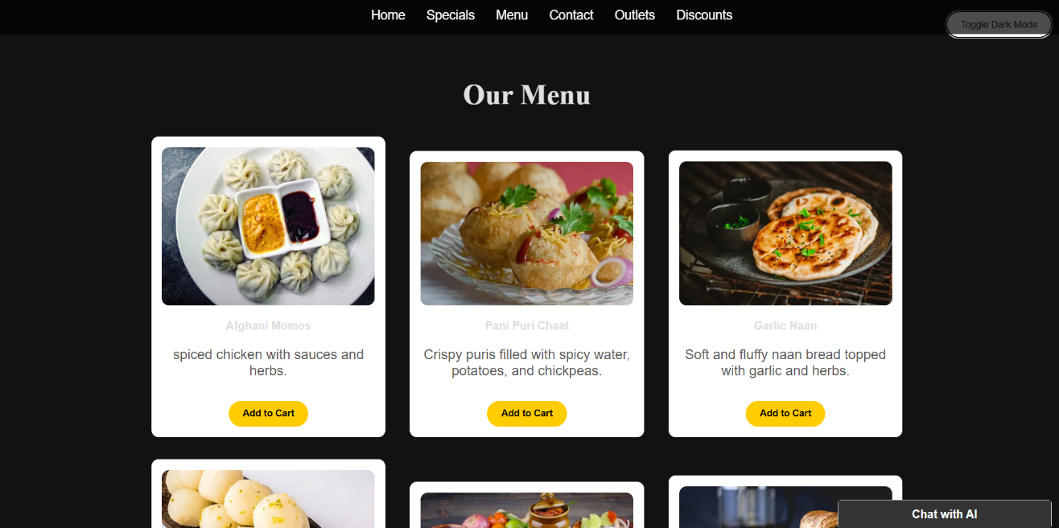

Code:

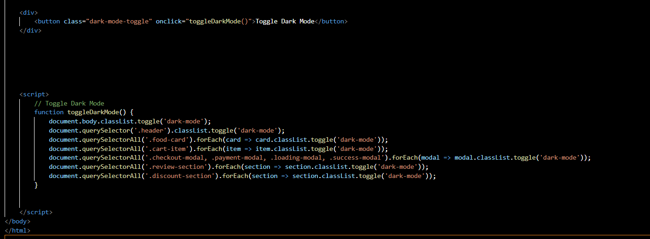

6

Reviews and ratings given by the customers to showcase the quality of dishes:

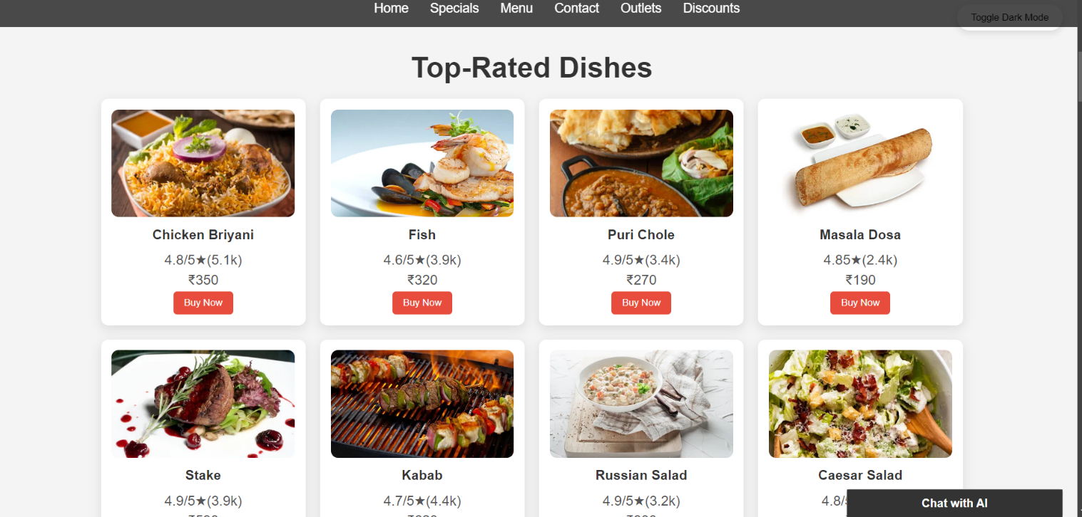

Code:

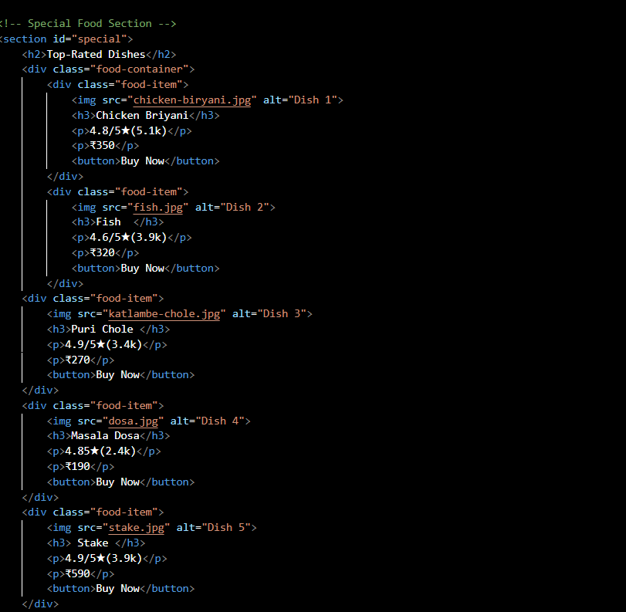

7

Customer reviews:

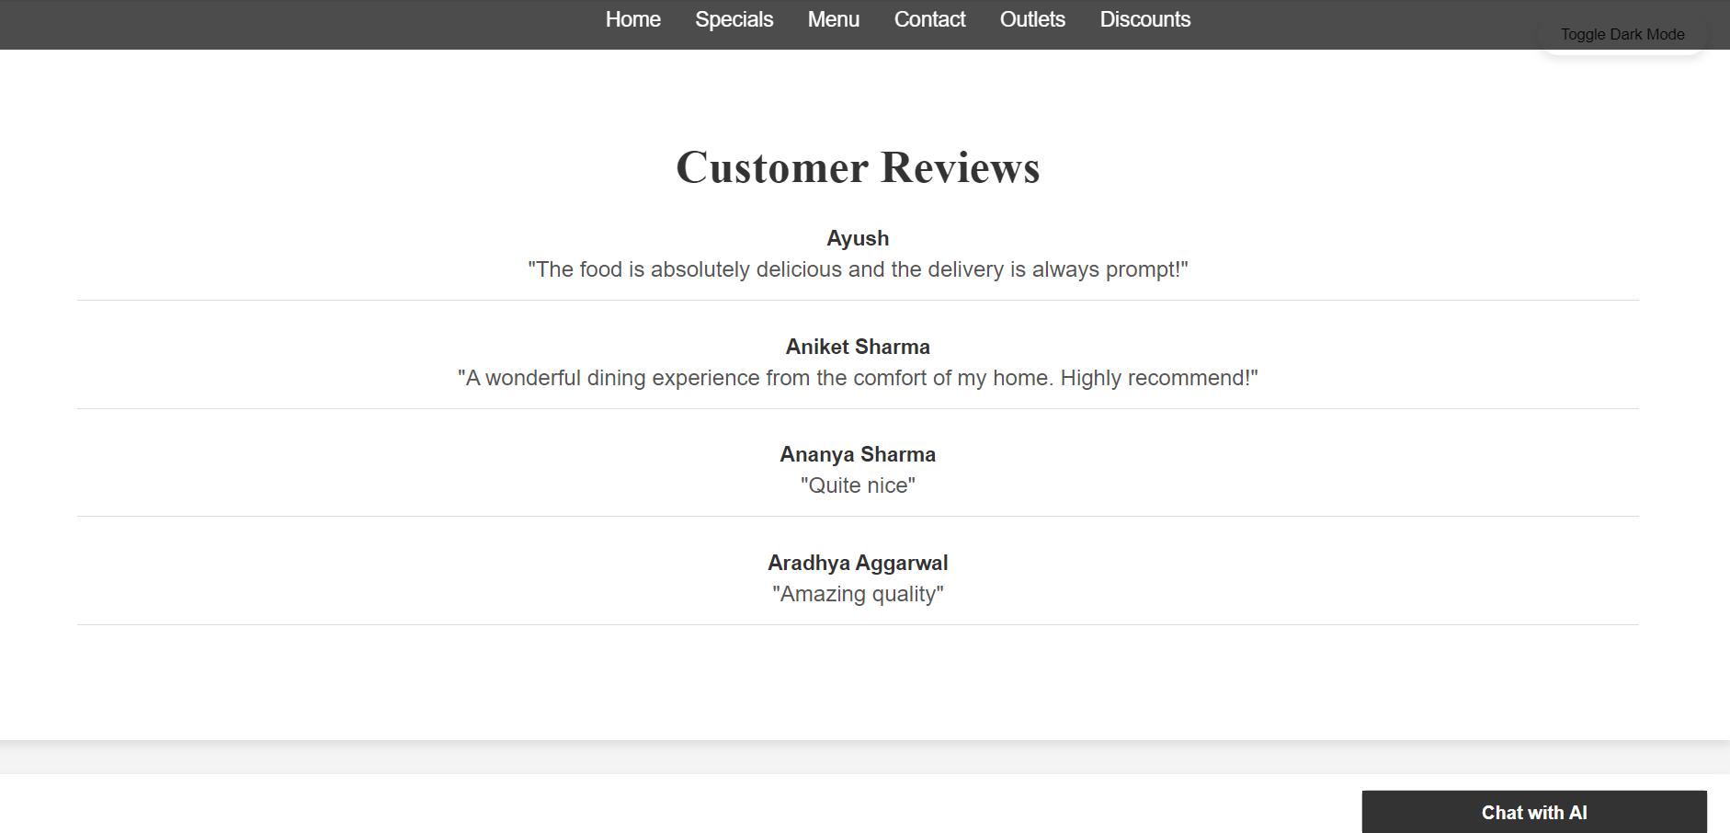

Code:

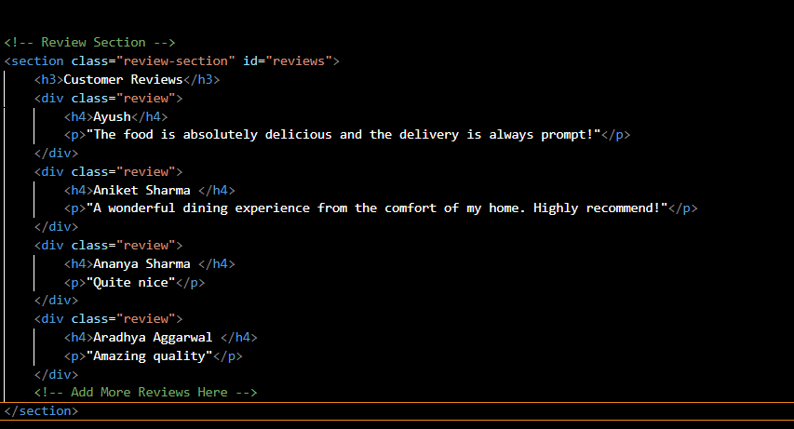

8

Payment method:

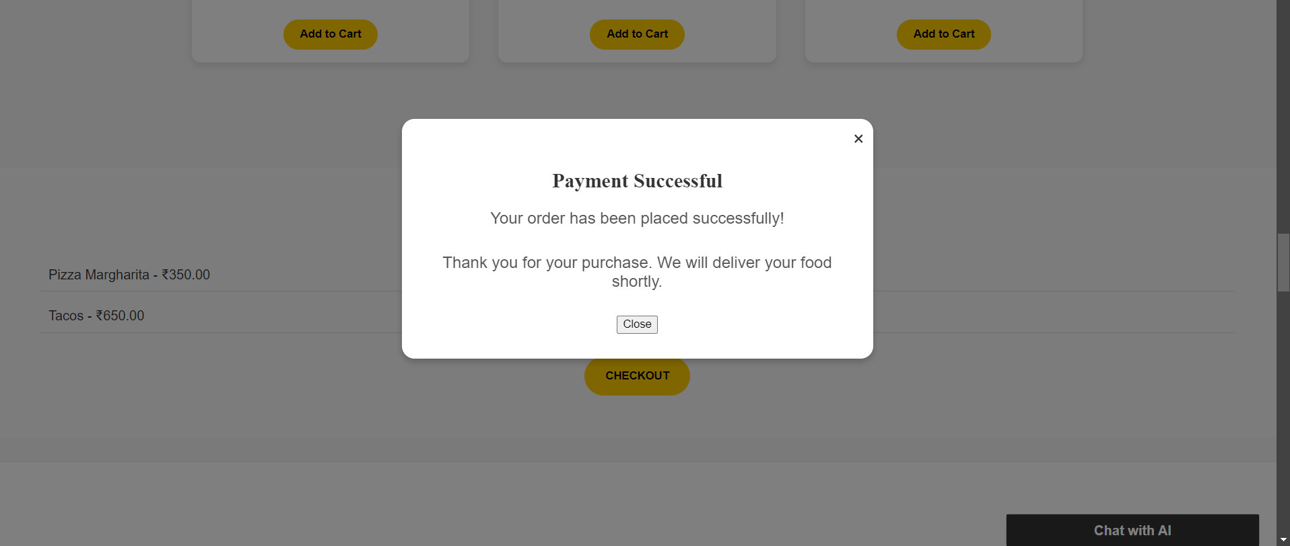

Code:

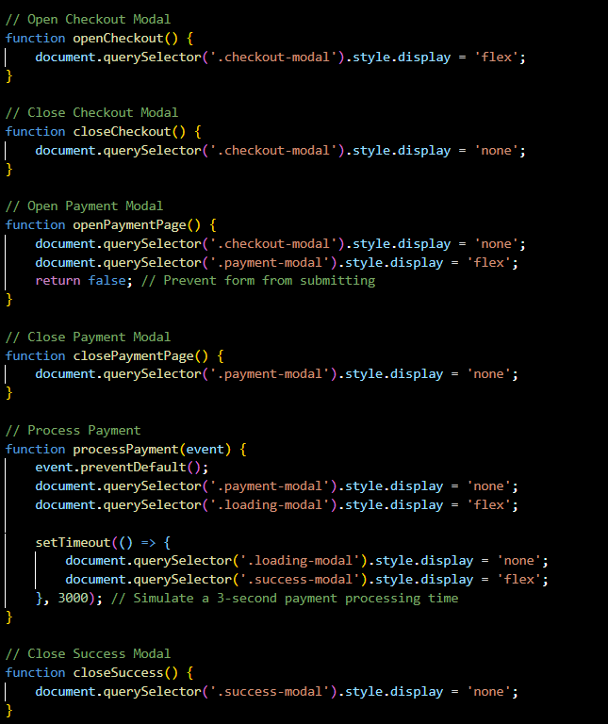

9

Bonus Feature:

Map Visual Representation:

You can navigate through map too see our outlets to find the exact location:

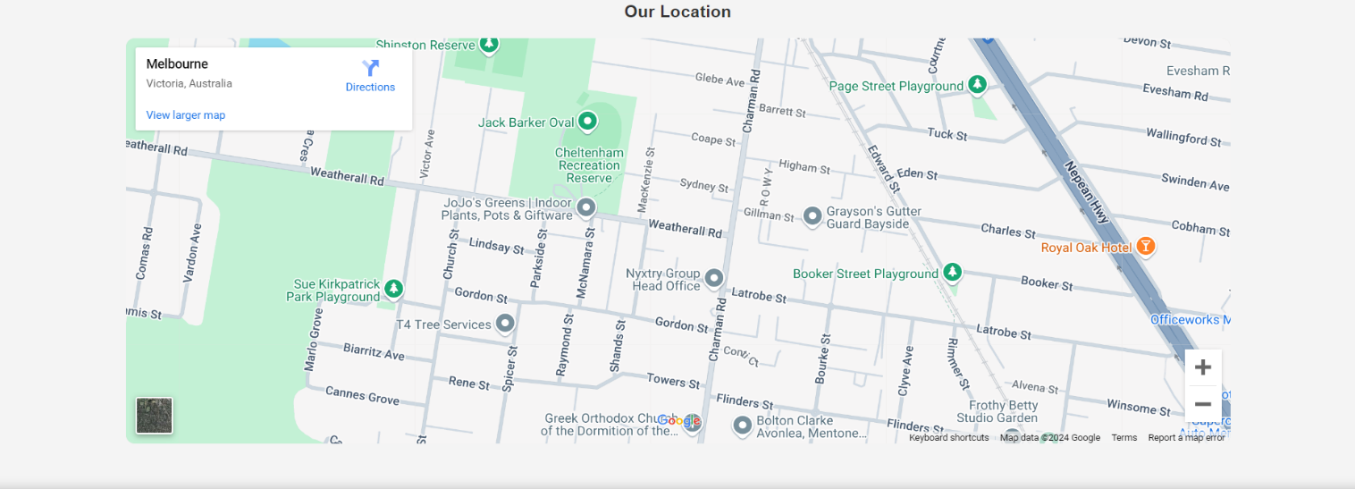

Moreover, we are providing you best customer service:

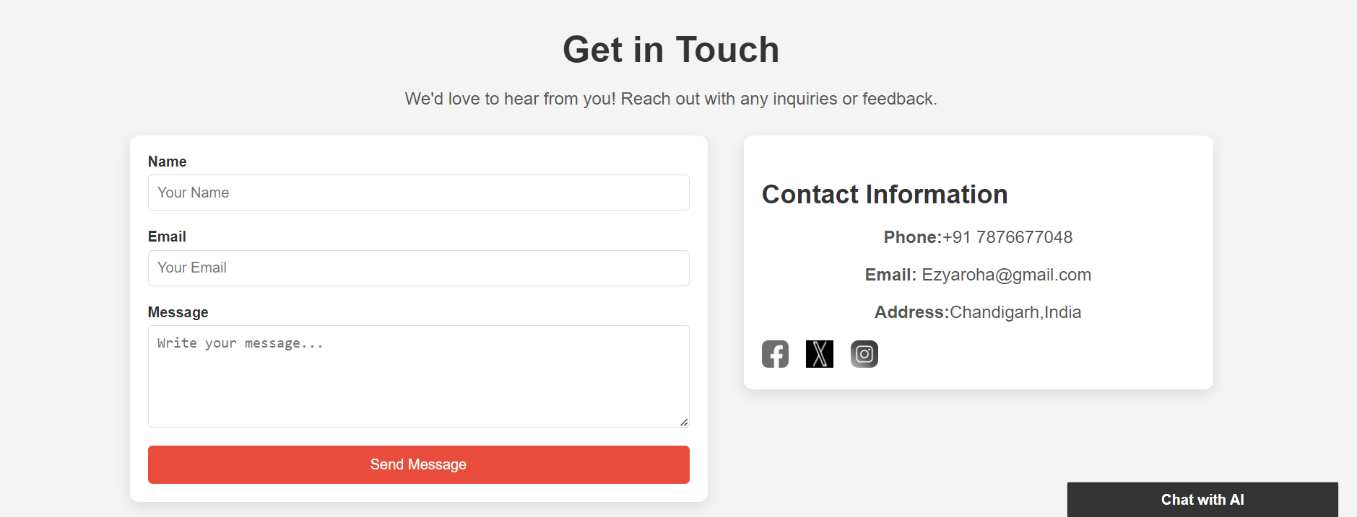

10

Conclusion

We developed a food delivery website which solves various and basic aspects of problems which other companies don’t do. Our website offers a very user-friendly interface, engaging user experience, diversity of food to try etc. “

We learned the real use of html, CSS and JavaScript after making a project in a detailed way, how to make users engage, and the challenges and errors."

11

References and links used

* <https://www.youtube.com/watch?v=bp2WhOkxeu0&t=1s>
* <https://www.zomato.com/>
* https://www.pexels.com/
* <https://www.w3schools.com/html/>
* https://www.mckinsey.com/industries/technology-media-and-telecommunications/our-insights/ordering-in-the-rapid-evolution-of-food-delivery